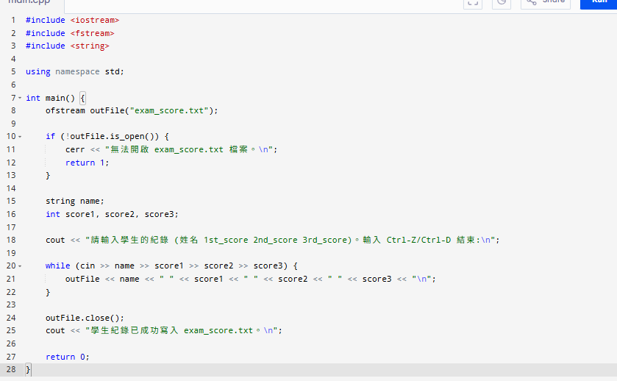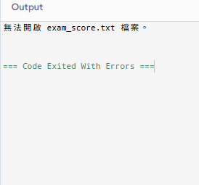
#include <iostream>
#include <fstream>
#include <string>

using namespace std;

int main() {
ofstream outFile("exam_score.txt");

if (!outFile.is_open()) {
cerr << "無法開啟 exam_score.txt 檔案。\n";
return 1;
}

string name;
int score1, score2, score3;

cout << "請輸入學生的紀錄 (姓名 1st_score 2nd_score 3rd_score)。輸入 Ctrl-Z/Ctrl-D 結束:\n";

while (cin >> name >> score1 >> score2 >> score3) {
outFile << name << " " << score1 << " " << score2 << " " << score3 << "\n";
}

outFile.close();
cout << "學生紀錄已成功寫入 exam_score.txt。\n";

return 0;
}

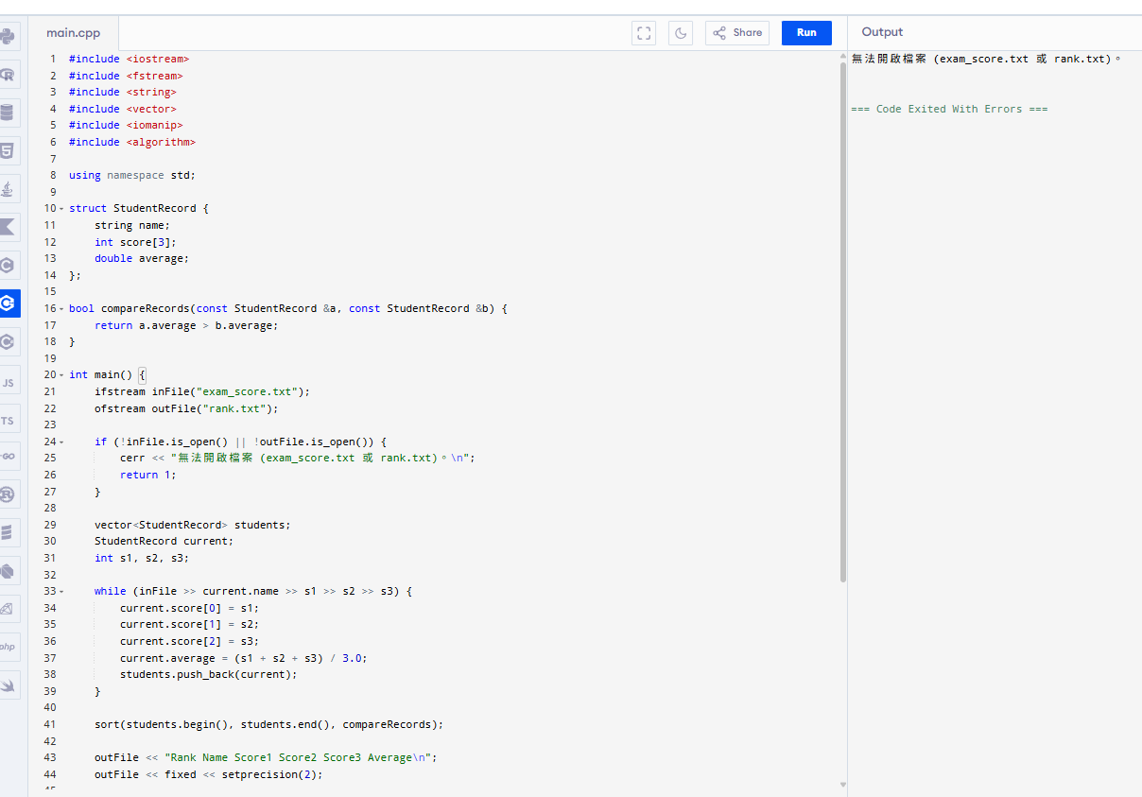

#include <iostream>
#include <fstream>
#include <string>
#include <vector>
#include <iomanip>
#include <algorithm>

using namespace std;

struct StudentRecord {
string name;
int score[3];
double average;
};

bool compareRecords(const StudentRecord &a, const StudentRecord &b) {
return a.average > b.average;
}

int main() {
ifstream inFile("exam_score.txt");
ofstream outFile("rank.txt");

if (!inFile.is_open() || !outFile.is_open()) {
cerr << "無法開啟檔案 (exam_score.txt 或 rank.txt)。\n";
return 1;
}

vector<StudentRecord> students;
StudentRecord current;
int s1, s2, s3;

while (inFile >> current.name >> s1 >> s2 >> s3) {
current.score[0] = s1;
current.score[1] = s2;
current.score[2] = s3;
current.average = (s1 + s2 + s3) / 3.0;
students.push_back(current);
}

sort(students.begin(), students.end(), compareRecords);

outFile << "Rank Name Score1 Score2 Score3 Average\n";
outFile << fixed << setprecision(2);

for (size_t i = 0; i < students.size(); ++i) {
const StudentRecord &s = students[i];
outFile << setw(4) << i + 1
<< setw(10) << s.name
<< setw(7) << s.score[0]
<< setw(7) << s.score[1]
<< setw(7) << s.score[2]
<< setw(10) << s.average << "\n";
}

inFile.close();
outFile.close();

cout << "已處理並排名學生紀錄，結果寫入 rank.txt。\n";
return 0;
}

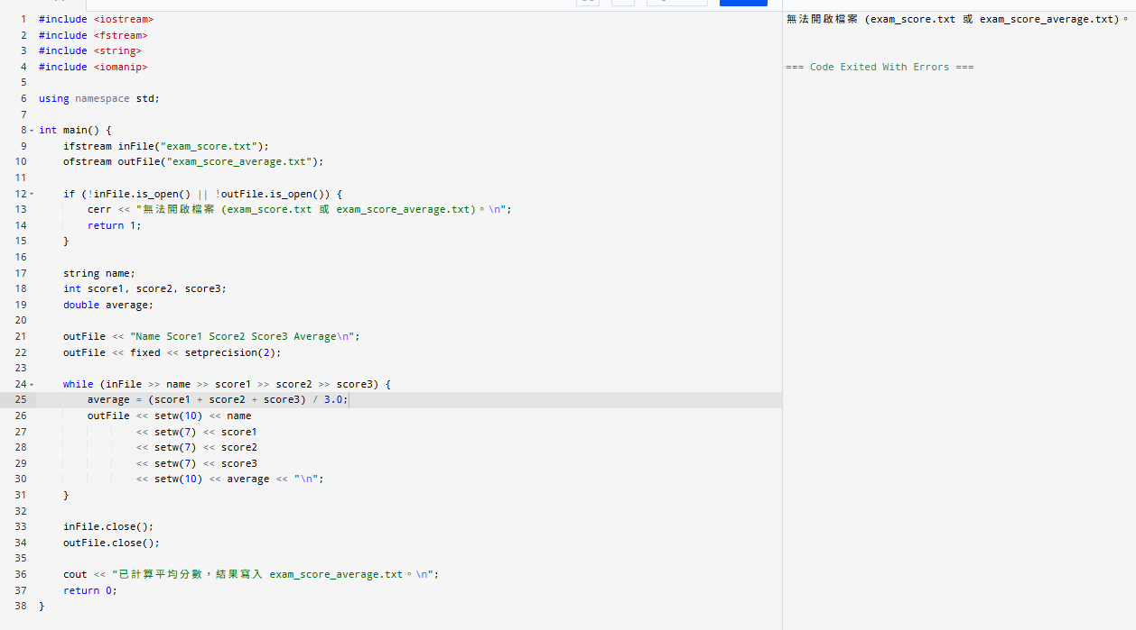
#include <iostream>
#include <fstream>
#include <string>
#include <iomanip>

using namespace std;

int main() {
ifstream inFile("exam_score.txt");
ofstream outFile("exam_score_average.txt");

if (!inFile.is_open() || !outFile.is_open()) {
cerr << "無法開啟檔案 (exam_score.txt 或 exam_score_average.txt)。\n";
return 1;
}

string name;
int score1, score2, score3;
double average;

outFile << "Name Score1 Score2 Score3 Average\n";
outFile << fixed << setprecision(2);

while (inFile >> name >> score1 >> score2 >> score3) {
average = (score1 + score2 + score3) / 3.0;
outFile << setw(10) << name
<< setw(7) << score1
<< setw(7) << score2
<< setw(7) << score3
<< setw(10) << average << "\n";
}

inFile.close();
outFile.close();

cout << "已計算平均分數，結果寫入 exam_score_average.txt。\n";
return 0;
}

